Create a Job Alert – NHS Scotland
The process below will enable you to setup Job Alerts via email for relevant job roles.
Note- The Lothian region will also show jobs from national employers (with bases within Lothian). This could include NHS Lothian, Healthcare Improvement Scotland, NHS24, NHS Education for Scotland, NHS National Services Scotland, Public Health Scotland and Scottish Ambulance Service.

Step 1
Create an NHS Scotland account login (use your personal email for this).
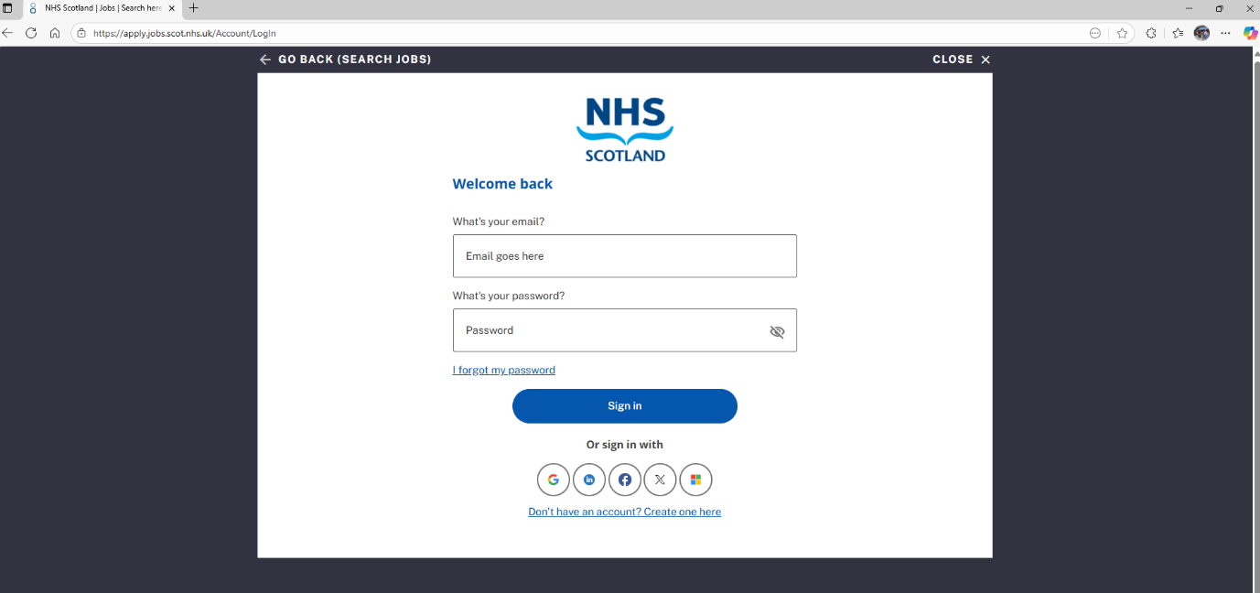
Step 2
Once logged in, navigate to the ‘create alerts’ button.
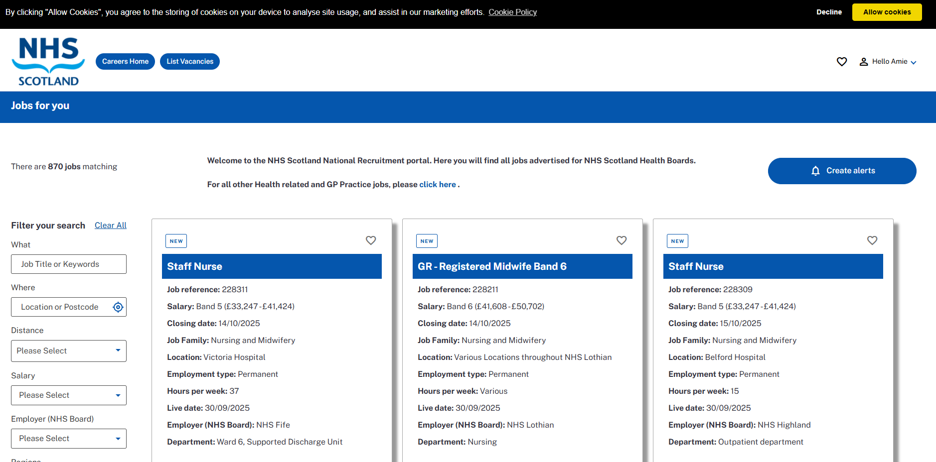



Step 3
Then click, ‘create new job alert’.


The next page will show this;

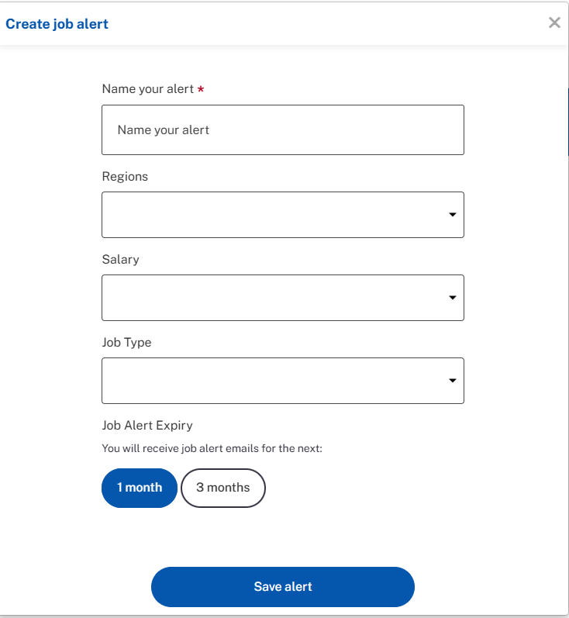

Step 4
Name your job alert, this is an example for ‘Admin Jobs’. Add the region (Lothian) and the salary bands (Bands 2 and 3 – generally requiring no previous experience) and type of job role ‘Administrative services’ e.g. Patient Care Advisor, Waiting List Assistant or Clerical Assistant.
This alert will then send emails for all new jobs that fit the criteria. For ‘support services’ roles e.g., Domestic Assistant, Security Officer or Porter entry level is band 2 (no prior experience).

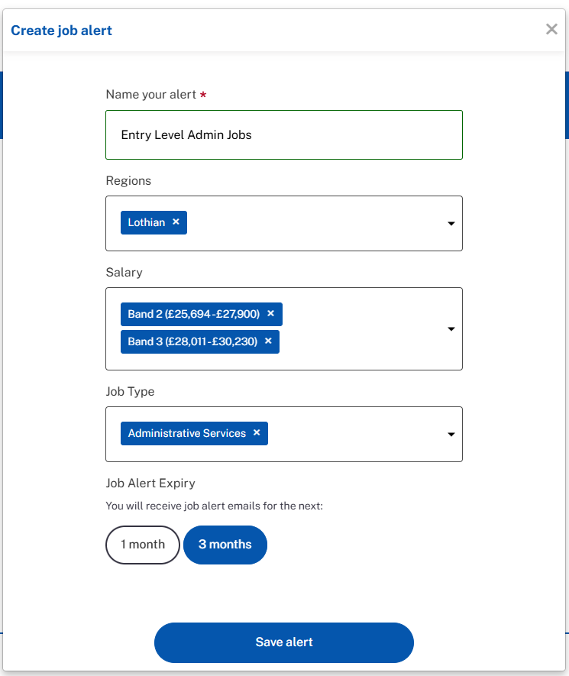

Choose whether you would like the job alert for 1 or 3 months, it will expire after this time. Then, save the alert.
Step 5
You can set multiple job alerts for different ‘job type(s)’ and will receive separate emails for each alert. You will receive emails daily or when new jobs are added to the website.
You may wish to save the emails to a separate folder of setup a ‘rule’ to file them for you. Information here.
Step 6
If you wish to continue alerts for longer than 3 months, please login and extend them. The information will be saved under ‘my job alerts’ and can be edited using the ‘pencil’ icon.
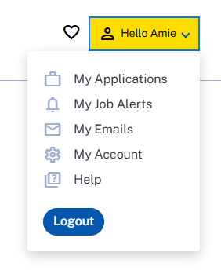

Additional Information RE NHS recruitment processes.
In NHS Lothian jobs are generally advertised for 2 weeks (this can be as little as 1 week or as long as 4). Job adverts may close early if lots of applications are received.
NHS Lothian will share interview questions on request with candidates who have a neurodiverse condition. These will be shared 24 hours before the interview. The request should go to the named contact on the job advert.
NHS Scotland uses the same 3 questions on the application. Please see this webpage for general information on the NHS Scotland application process. More detailed information relating to NHS Lothian (including application and interview preparation) can be found here.
ENDS

